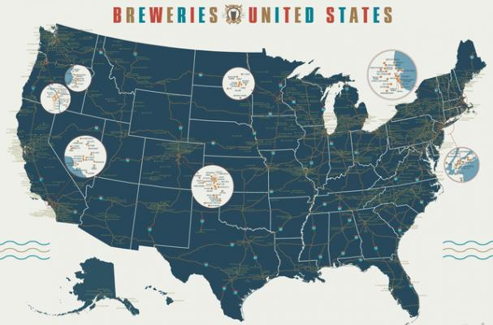

Case Study 1

Brewery review

Name | Course 6306 | Date

| 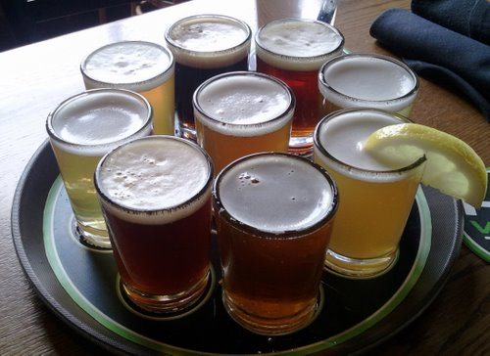

# Introduction

To replace the placeholder text on this page, you can just select it all and then start typing. But don’t do that just yet!

First check out a few tips to help you quickly format your report. You might be amazed at how easy it is.

* Need a heading? On the Home tab, in the Styles gallery, just click the heading style you want.
* Notice other styles in that gallery as well, such as for a quote, a numbered list, or a bulleted list like this one.
* For best results when selecting text to copy or edit, don’t include space to the left or right of the characters in your selection.

## Research Methodolgy

You might like the photo on the cover page as much as we do, but if it’s not ideal for your report, it’s easy to replace it with your own.

Just delete the placeholder picture. Then, on the Insert tab, click Picture to select one from your files.

## Questions Addressed

You might like the photo on the cover page as much as we do, but if it’s not ideal for your report, it’s easy to replace it with your own.

Just delete the placeholder picture. Then, on the Insert tab, click Picture to select one from your files.

1. How many breweries
2. First 6 Observations
3. Number of N/A
4. Median
5. Bar Chart
6. State has ABV
7. State most bitter IBU
8. Summary Statistics
9. Relationship between bitterness & Alc Content
10. Scatter Plot

## Conclusion

You might like the photo on the cover page as much as we do, but if it’s not ideal for your report, it’s easy to replace it with your own.

Just delete the placeholder picture. Then, on the Insert tab, click Picture to select one from your files.

## Codebook

You might like the photo on the cover page as much as we do, but if it’s not ideal for your report, it’s easy to replace it with your own.

Just delete the placeholder picture. Then, on the Insert tab, click Picture to select one from your files.

|  |  |  |
| --- | --- | --- |
| Variables | Tables |  |

Source: